**Docker commands**

**Docker Basic commands**

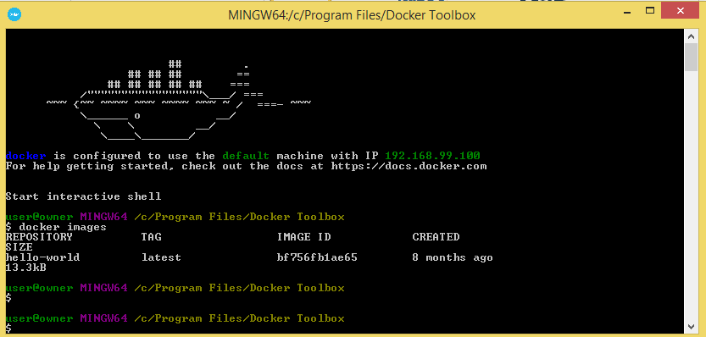

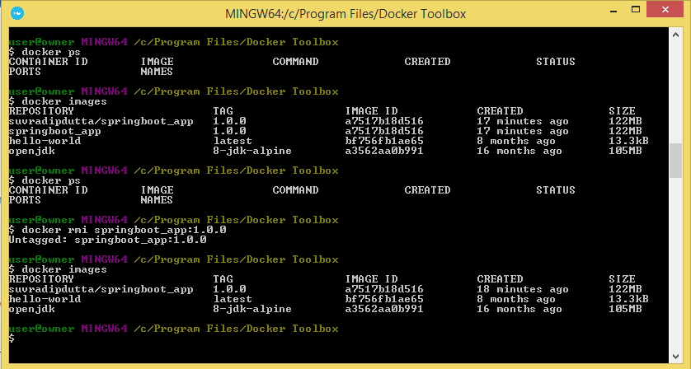

**Docker Image for Springboot application**

**Docker File**

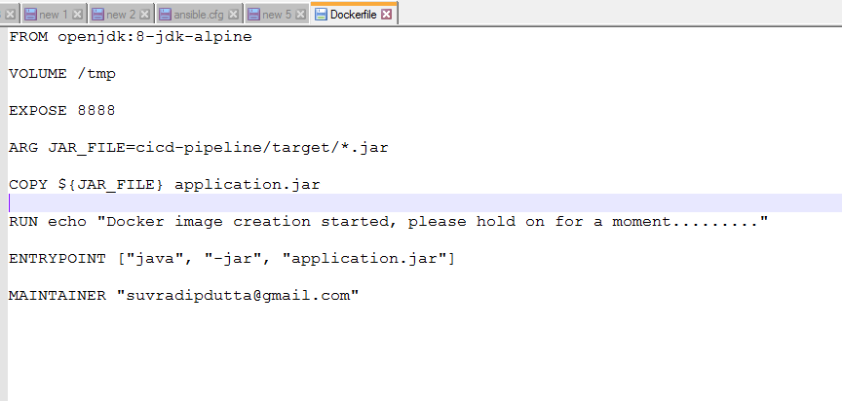

**Docker Build**

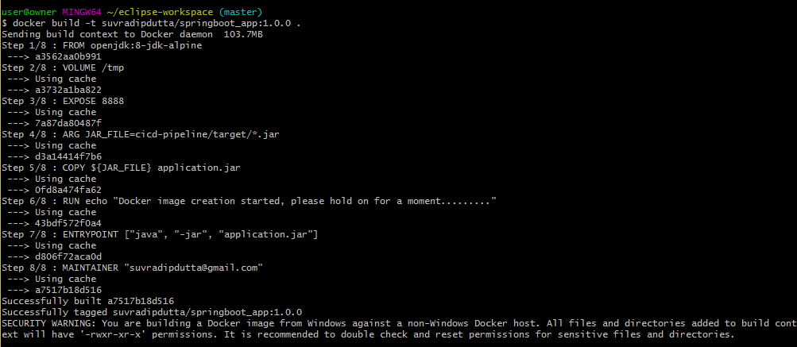

**Docker Push**

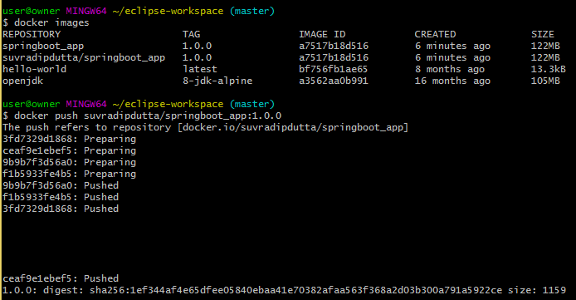

**Docker Hub Repository**

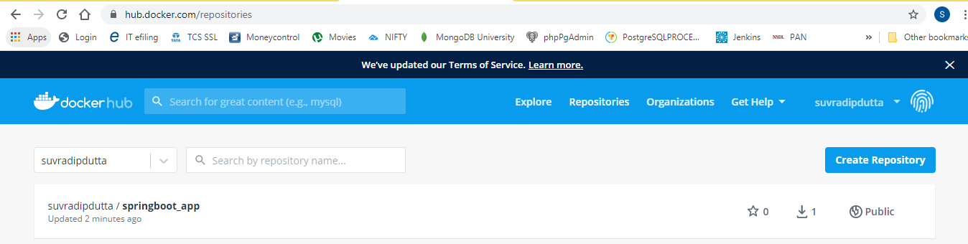

**Docker Pull**

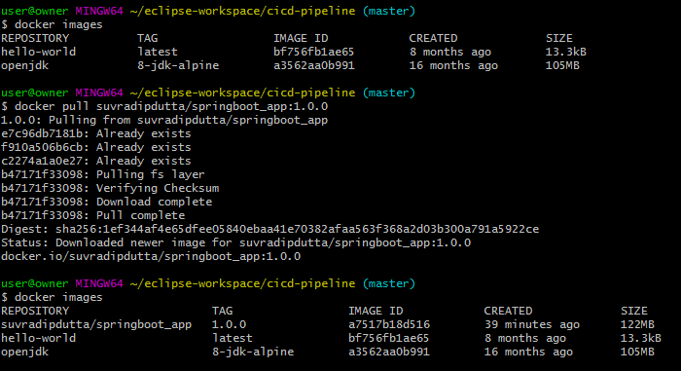

**Docker Run**



**Browser Output in diff environment**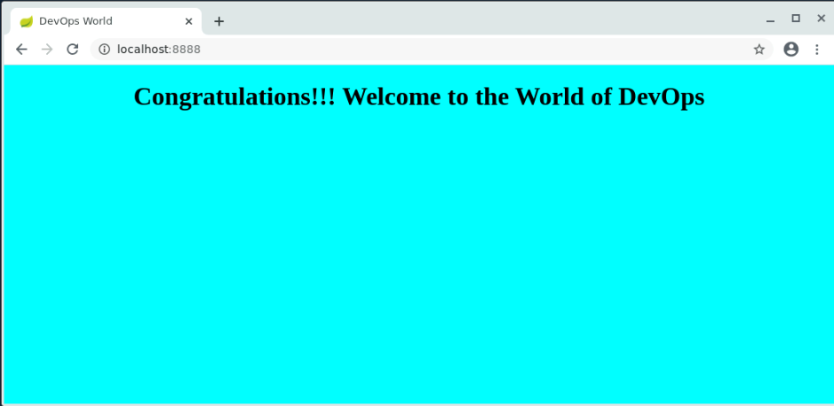

**Docker Image for Dynamic Java project**